**Why this project?**

-Learning to create this interface allows us to conduct our research on intelligibility.

**--Alif’s section--**

What: Alif will develop a program that plays a sound file

Why: This will allow a user to listen to the sentence

How: First, Alif will store the sound file in his computer. Then he will make the sound icon “clickable.” Then the sound will play.

**--Erik’s section—**

What: Erik will code a program for collecting and storing participants’ inputs.

Why: Collecting and storing these inputs is necessary for them to be accessed later for analysis.

How: The course has covered topics such as receiving and logging text. Erik will need to learn how to move that data to servers and pull data from those servers at a later time. He will utilize online resources, the course instructor, and/or TAs.

**--Agata’s section—**

What: Agata will work on the website design

Why: This will create appealing appearance and hopefully it will facilitate a user-friendly interface.

How: This task is beyond the scope of the class so Agata will educate herself and, if needed, seek help from Alif, the instructor of the course and the TAs. Here is a screenshot of one idea of the intended design (please note that this design may change, this is just an example):

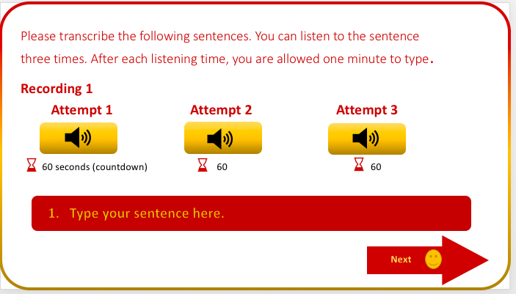

**Implications**

-We hope to apply our experience creating this interface to the future. We hope to adapt our program for other sound perception studies.